The International College of Economics and Finance
Econometrics – 2017-2018.
Midterm exam 2018. March 29.

General instructions. Candidates should answer SIX of the following SEVEN questions: all 4 questions of the Section A and any 2 of the questions from Section B (questions 5-7). The weight of the Section A is 60% of the exam; three other questions from the Section B add 20% each. You are advised to divide your time accordingly. Structure your answers in accordance with the structure of the questions. When testing hypotheses always state clearly null and alternative hypotheses provide critical value used for the test, mentioning degrees of freedom and the significance level chosen for the test.

SECTION A
(1 hour 50 minutes + 10 minutes for reading)
Answer ALL questions from this section (questions 1-4).
Each question in this section bears 15 marks

Question 1.
(15 marks) Let the regression equation be:
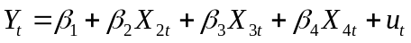 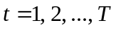.

(a) Outline how you would test the following restrictions

a.1) 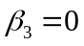,
a.2) 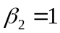
a.3) and simultaneously.

Specify the assumptions required for these tests. How to estimate the relevant equations needed for the test?

(b) Outline how you would test the following restrictions

b.1) 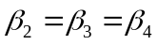 simultaneously against NOT
b.2) 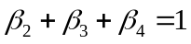 against 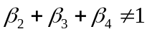,

Indicate test statistics. Specify the numbers of degrees of freedom. How to estimate the relevant equations needed for the tests?

(c) Outline how you would test the following restrictions

against 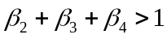.

Indicate test statistic. Specify the number of degrees of freedom. How to estimate the relevant equations needed for the test?

Question 2.
(15 marks) March 18, 2018 in Russia held the election of the President of the Russian Federation. The 3rd grade student of ICEF decided to collect data from the official reports of 87 regional election commissions. He built the equations expressing the dependence of the votes for each candidate in turn (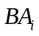 - Baburin share, 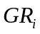 - Grudinin share, 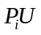 - Putin share, 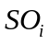 - Sobchak share, 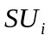 - Suraykin share, 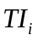 - Titov share, 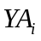 - Yavlinsky share, 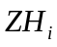 - Zhirinovsky share) on the voters' activity, meaning the proportion of those who voted for a certain candidate in the total number of registered voters (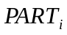 - participation). For example the equation for Sobchak:
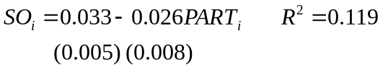 (1)
Then he added additional variable 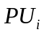 – the share of the votes for Putin
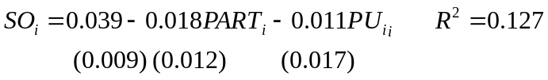 (2)

(a) Comment on the differences in R² for each equation. Are the variables in equations (1) and (2) significant taken by one and together? What is the difference in interpretation of the coefficients of the common variable in (1) and (2)? The student noticed that all slope coefficients in (1) and (2) have minus sign. Help him to find some explanation to this for each coefficient in turn.
Disappointed by the insignificance of the slope coefficients in (2) the student decided to add all other alternative candidates to equation
but student’s friend said that he can guess the values of almost all the coefficients without evaluating the equation. Try to do the same and explain?

(b) Then he decided to investigate how regional factor influence the share of votes for Putin. He divides all regions into 4 categories R1 (central regions with big cities such as Moscow and St.Petersburg), R2 (North, Siberia and Far East), R3 (Caucasus and South), R4 (Crimea and Sevastopol). Then he estimated the following equations:
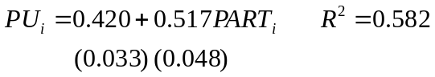 (3)
(4)
A friend of our student looked at the models and pointed out that model (4) could not be good as a dummy for central regions with big cities was omitted. Comment upon this criticism. Give interpretation to the coefficients of equations (3) and (4). Is regional factor significant based on comparison of these equations? What test is applicable here? Chow test applied to equation (3) gives F statistic equal to 9.28, compare this value with the value from your test and comment.

(c) During the discussion of the results of student’s study his scientific adviser mentioned on the possible endogeneity in the equation 3. So the student evaluated auxiliary equation
(5)
using 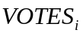 (total number of votes), 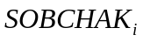 (number of votes for Sobchak), 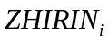 (number of votes for Zhirinovsky) as the instruments for , and then added the residuals of this equation 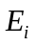 in equation (3)
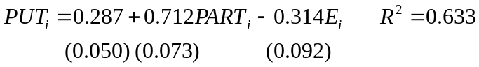 (6)
Explain what is endogeneity. Explain the procedure above, indicating null hypothesis and test statistic, and comment the results of the test. Discuss used set of instruments to conclude under what conditions the used test is valid?
Question 3.
(15 marks) The student is interested in the influence of the price level and income on the consumption of soft drinks 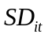. Suppose that the time series 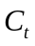 (Coca-cola), 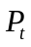 (Pepsi), 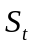 (Sprite), 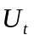 (7-up), 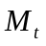 (Myrinda), 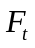 (Fanta) for 1988-2017 form the panel (as observations for particular units of some general type of soft drinks ()). 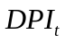 is the disposable personal income and 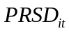 is the relative price index for corresponding .Let the model under investigation be

.

(a) What are the advantages of panel data analysis comparing to cross-section regression and time series analysis? What are typical problems associated with the panel data models? The student decided to use the approach based on the fixed effects panel data model. Help the student to understand what is LSDV method and how to use it for estimation of panel data model under consideration. Explain clearly what are fixed effects.

(b) How to test the presence of unobserved heterogeneity if fixed effect model or to put it another way, that there are considerable differences between the pooled model and the model with fixed effects? Give some details: indicate corresponding test and the data needed for it, null hypothesis, distribution of the test statistic, the number of degrees of freedom and the decision rule.

(c) What other methods within the fixed effects panel data model can the student apply? What are their comparative advantages and disadvantages? Could the researcher have used a random effects regression in the present case? How to choose between random effects and fixed effects panel model?

Question 4.
(15 marks) Using daily data for the period from 2017-04-01 to 2017-09-30 (183 observations), a student tries to investigate the behavior of bitcoin prices (in dollars), their differences 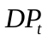 and corresponding dynamics of the volume of trade 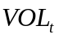 (see the corresponding graphs below). For time trend 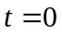 at 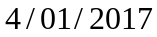.
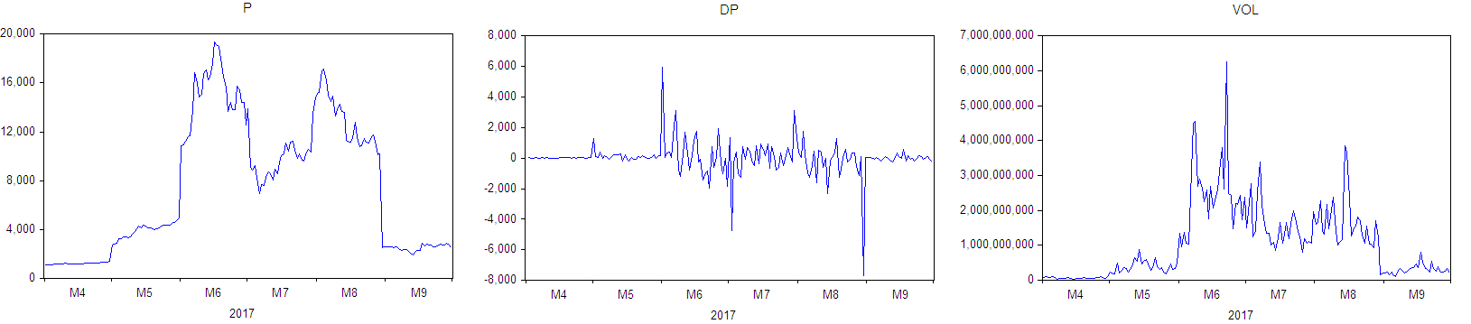

Suspecting that some of these time series might be non-stationary she runs some Dickey-Fuller equations to test the series for stationarity:

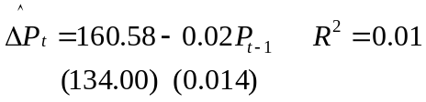, (1)

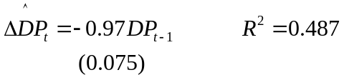 (2)

(3)

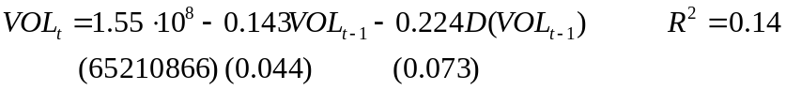 (4)

(a) Looking at the graphs what are your initial guesses about stationarity of the given time series? Describe briefly how to use Dickey-Fuller equations to test time series under consideration for stationarity. For equations (1) - (4) perform the (Augmented) Dickey-Fuller t-test, each time clearly indicating the null hypothesis, the test statistic and critical values. Simultaneously explain how to find the critical values in the presence of a time trend? How to test the presense of time trend in time series? Compare the results of equations (3) and (4). Comment on the results.

(b) Now for equations (1-4) carry out the Dickey-Fuller test using the scaled estimator of the slope coefficient 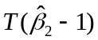 to test series , and for nonstationarity where 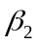 is the slope coefficient of the autoregression 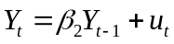. Indicate in each case the null hypothesis and used critical values. Do the results of these tests coincide with your conclusions based on t-tests? Comment the meaning of statistic and explain why the difference 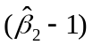 should be multiplied by rather than by 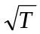.

(c) The student obtained for equation (1)
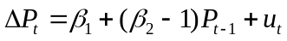,
the value of F-statistics for testing simultaneously two restrictions 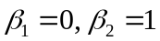: 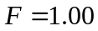. How to use this information to conduct Dickey-Fuller F-test for the nonstationarity of the ? Following this approach describe how you can investigate also eqations (2-4) to test the series and for the nonstationarity using Dickey-Fuller F-test: for each case indicate theoretical equation, restriction(s), and the rule for choosing the critical value of ADF F-statistic from the appropriate table. Indicate also in each case the random processes which the test allows to discriminate. What are comparative advantages and disadvantages of three different ADF tests for nonstationarity?
SECTION В
(1 hour 10 minutes + 10 minutes for reading)
Answer TWO questions from this section (questions 5-7).
Each answered question in this section bears 20 marks.

Question 5.
(20 marks) Suppose the model 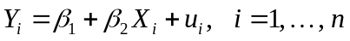 satisfies all assumptions of the model A (Gauss-Markov conditions). Let the values of 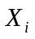 are supposed to be non-stochastic. The researcher wrongly believes that 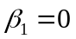 and so uses OLS estimator 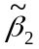 for the model 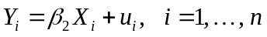 instead of OLS estimator 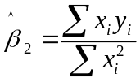 for the model where 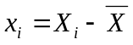, 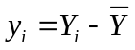.

(a) Show that OLS estimator for the model is 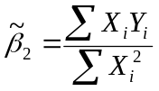.

(b) If the assumption is not correct show that estimator is biased and find the bias. Indicate the case when despite 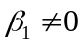 the estimator is nevertheless unbiased.

(c) Show that the variance of is given by expression 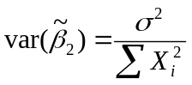, where 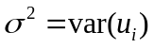.

(d) Show that if assumption is true the estimator is still unbiased but inefficient.
(Hint: compare the variances of two estimators and 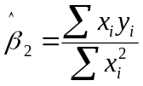).

Question 6.
(20 marks) Consider a model
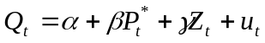; 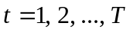 (1)
where 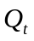 is the supply of wheat from the farmers of a particular country, 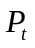 is the price of wheat (£) and 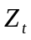 is a measure of rainfall in this country. These three variables are observed. Price expectations 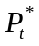 are revised by 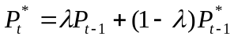. 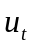 is a random error, such that 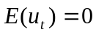; 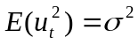 and 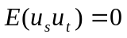 if 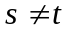 for all 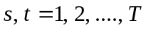.

(a) Show that this model can be reduced to infinite distributed lags model of the type
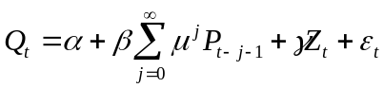 (2)
(b) How the models of the type (2) could be estimated? Discuss the problems connected with estimation of obtained model.

(c) Show that the infinite distributed lags model of the type (2) can be written in terms of a single lag 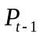. What estimation problems may occur in this model?

(d) Derive an econometric model in observable quantities directly using Koyck transformation (without using infinite lags). Discuss the problems connected with estimation of obtained model.

Question 7.
(20 marks) A researcher has time series data for aggregate consumption, C, and aggregate disposable personal income, Y, for a certain country. She establishes that the logarithms of both series are I(1) (integrated of order one). The researcher also believes that 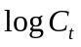 and 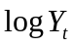 are cointegrated, so the cointegrating relationship exists
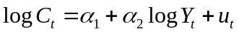 (1)
where it may be assumed that 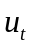 is normally distributed with zero mean and constant variance.

(a) Explain what is meant when a series is described as being integrated of order one. Explain what is meant when two time series are described as being cointegrated in the context of the problem under consideration. How to test both statements (the series is integrated of order 1, and two series under consideration are cointegrated)? Show that while and are not stationary the logarithmic growth rates of consumption 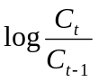 and income 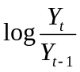 are stationary. Can be a regression of one of them on another considered as cointegrating relationship?

(b) The researcher is also interested in the short-run dynamics of the relationship and correctly hypothesizes that they may be represented by ADL(1,2) process with two lags for income variable
(2)
where ε_{t} is identically and independently distributed and drawn from a normal distribution with zero mean. Derive long run relationship between the equilibrium values of and : 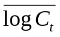 and 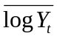, and find short run and long run income elasticities of consumption.

(c) Using long run relationship between 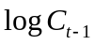 and 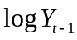 as a possible cointegrating relationship derive error-correction type model for the model (2).

(d) Describe the structure and dynamics of error correction model. Explain why fitting the error-correction model, rather than (2) directly, avoids a potentially important problem. Which assumptions are necessary to use error correction model? How these assumptions could be tested?

